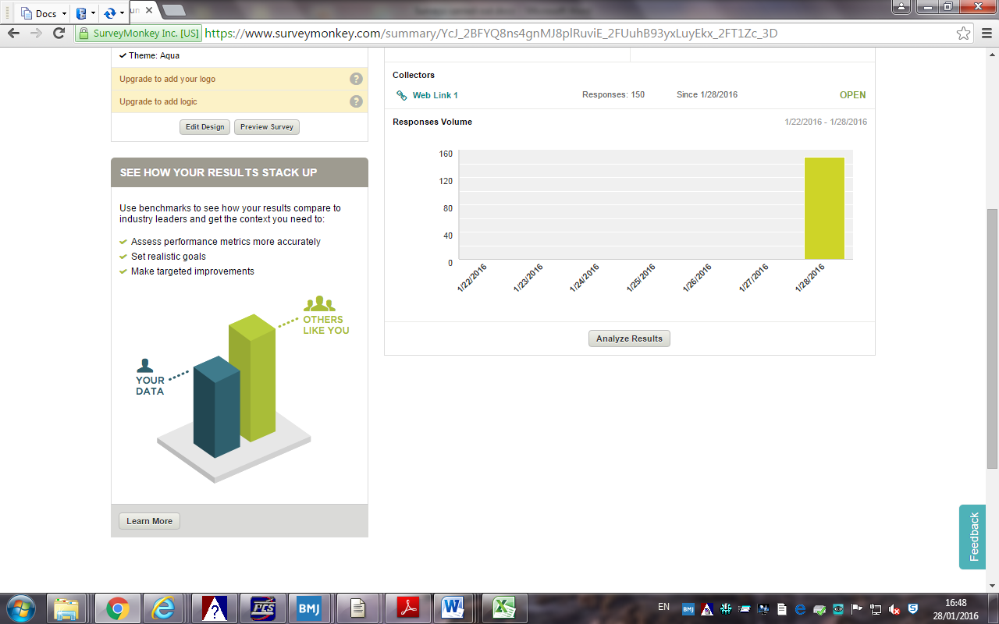

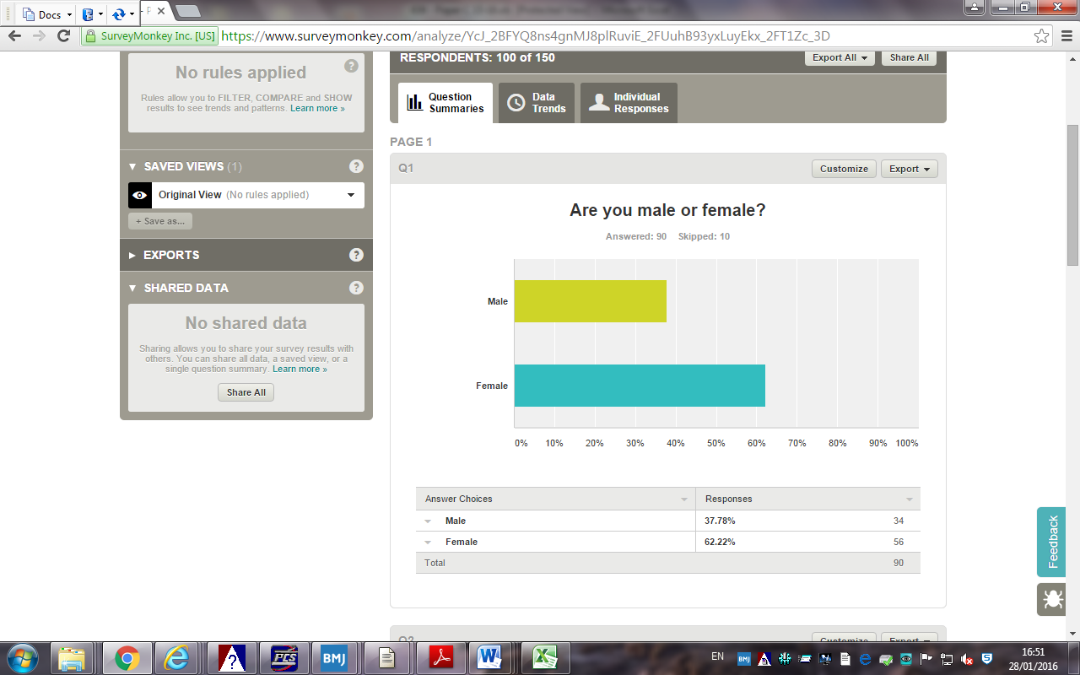

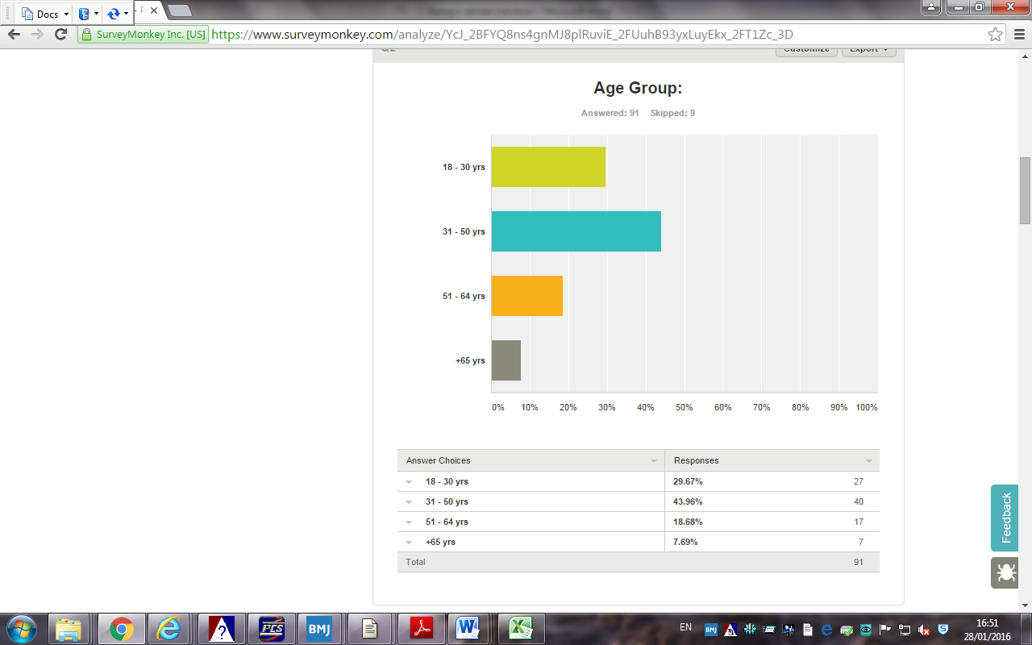

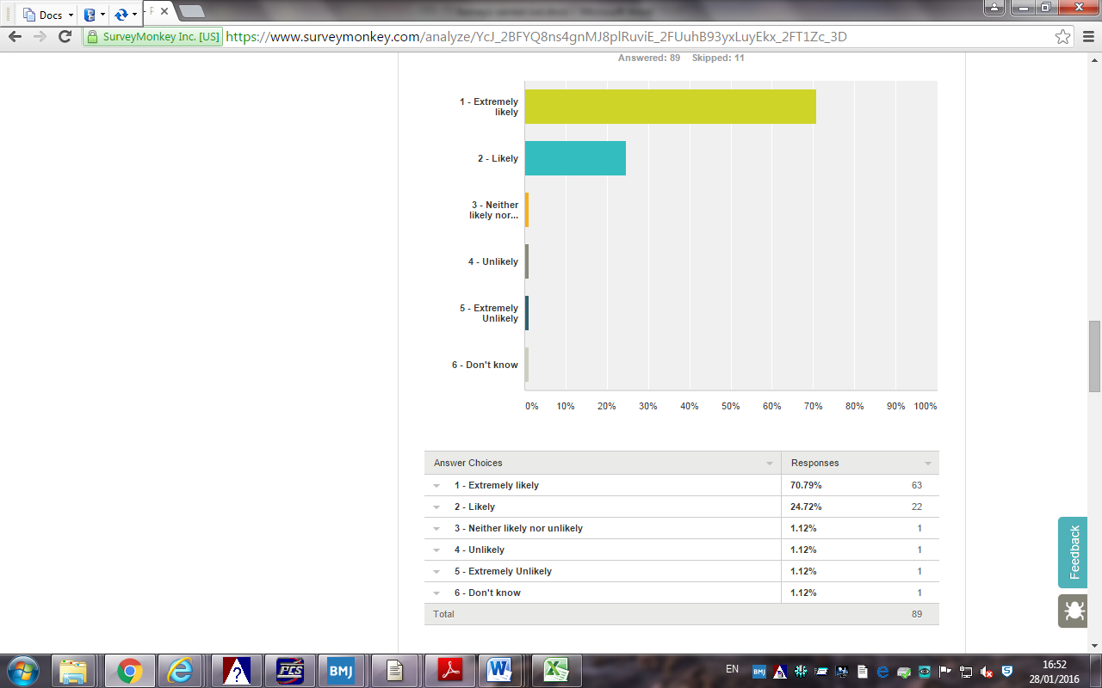

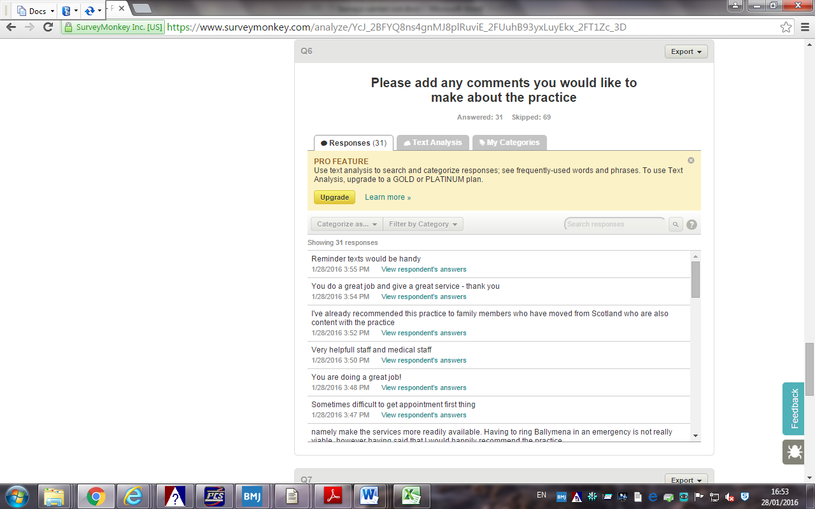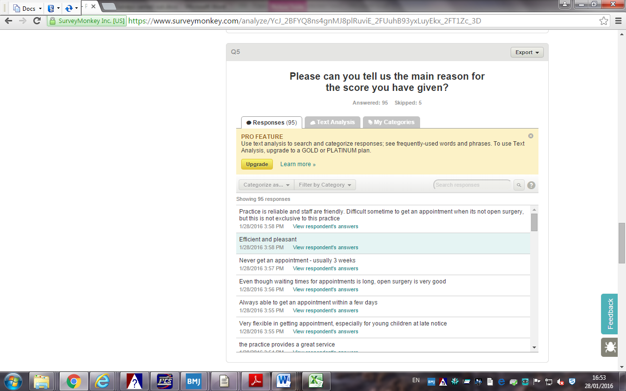



The practice undertook the above patient survey via anonymous respondents selected via:

1. Face-to-face consultation) = 60%
2. Telephone consultation )
3. Prescription Request )
4. Practice website ) = 40%

150 responses received = 2% of practice population of 7500

Patients were selected irrespective of age/sex/gender/ability or ethnicity, and they were also selected from postcodes: BT15 – BT39, ensuring full practice area covered.

70.79% of total respondents scored 1 – extremely likely to recommend GP practice to someone who has moved into the local area and 24.72% scored 2 – likely; equating to 95.51 % of total respondents.

The practice will continue to endeavour to maintain our high standards and offer the best possible service to our patients throughout exceptionally difficult and challenging times within Primary Care.

We do not feel that any further action is required after analysis of this survey.

A poster has been placed in Patient waiting Area displaying the results of our survey.

***The Practice would like to thank all those patients who kindly participated in our patient survey this year.***

***Your response/feedback and comments have been extremely positive with 95% of respondents stating:***

***They would be extremely likely/likely to recommend THIIS PRACTICE to someone who has just moved into the area.***

***Good service is our most important goal.***

***Your concerns and comments mean a lot to us.***

***If we are not meeting your needs,***

***Please let us know how we could do better.***

***If we are doing our job well,***

***Please also let us know***

***THANK YOU ONCE AGAIN FOR TAKING OUR SURVEY,***

***AND SHARING YOUR IDEAS WITH US***

***C:\Program Files\Microsoft Office\MEDIA\CAGCAT10\j0281904.wmf***